BECE206P Analog Circuits Lab Experiment 5

Name: ANKIT NEGI

Reg. No.: 22BEC1117

# **Second Order Low Pass Filter & R-2R Ladder DAC**

# AIM: To design and verify a second Order Low Pass Filter & R-2R Ladder DAC circuit

# SOFTWARE REQUIRED: LTspice

# PROCEDURE:

1. Open a new LTspice schematic and create an offset Op Amp Circuit as provided
2. Edit simulation command to Transient Analysis and begin simulation

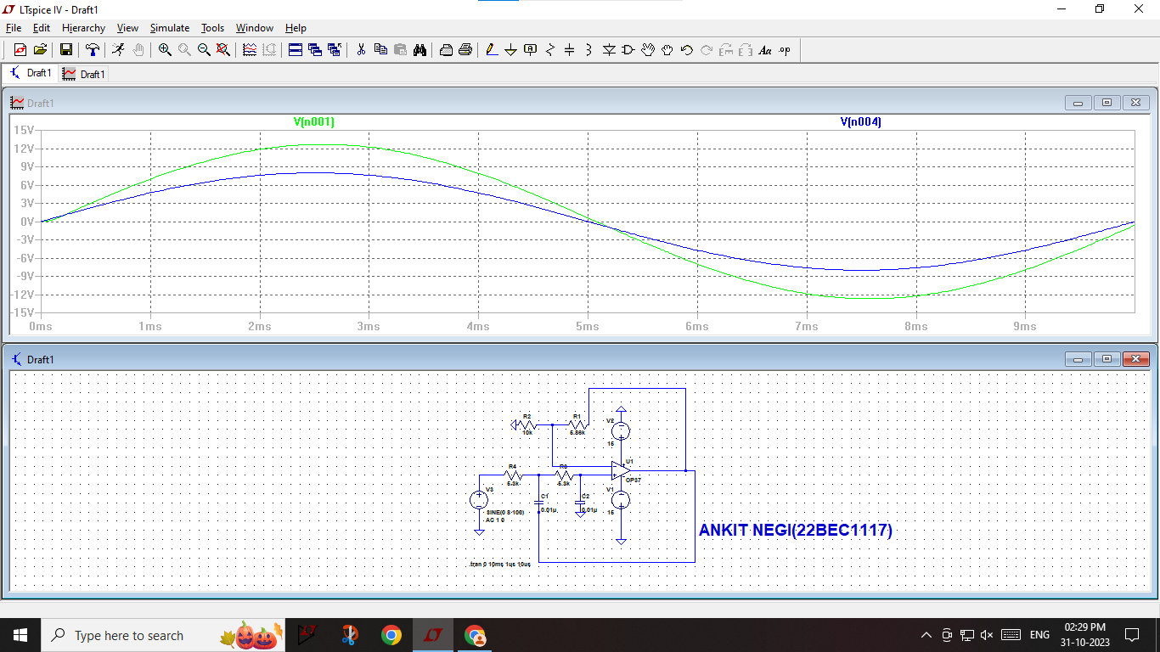

1. Edit simulation command to AC analysis and begin simulation(when resistance are same that is 5.3k both side)

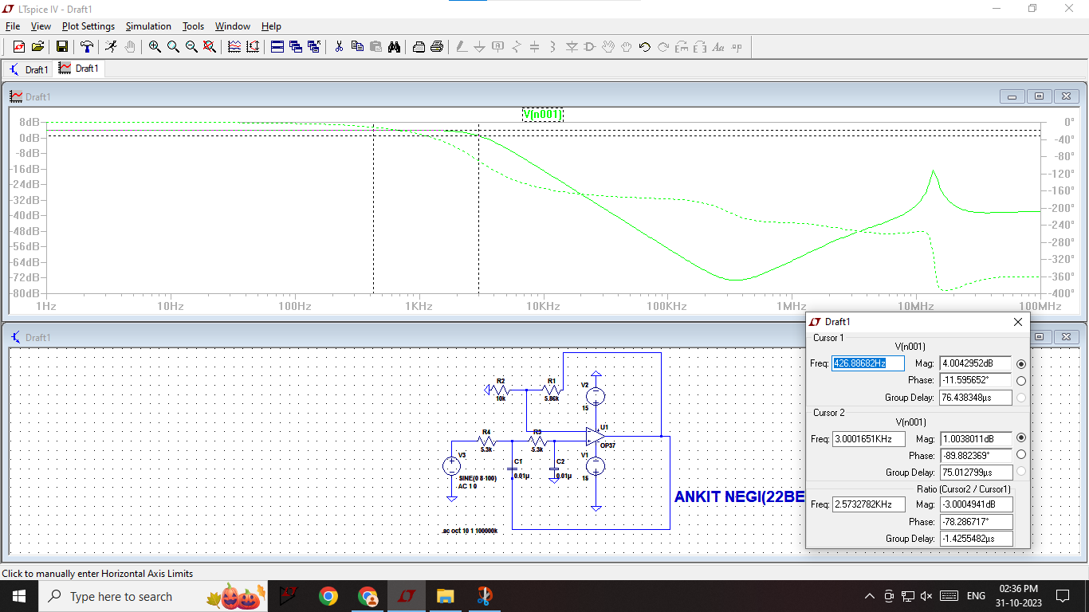

1. Edit simulation command to AC analysis and begin simulation(when resistance are different that is 5k and 4k both side less than 5.3k).

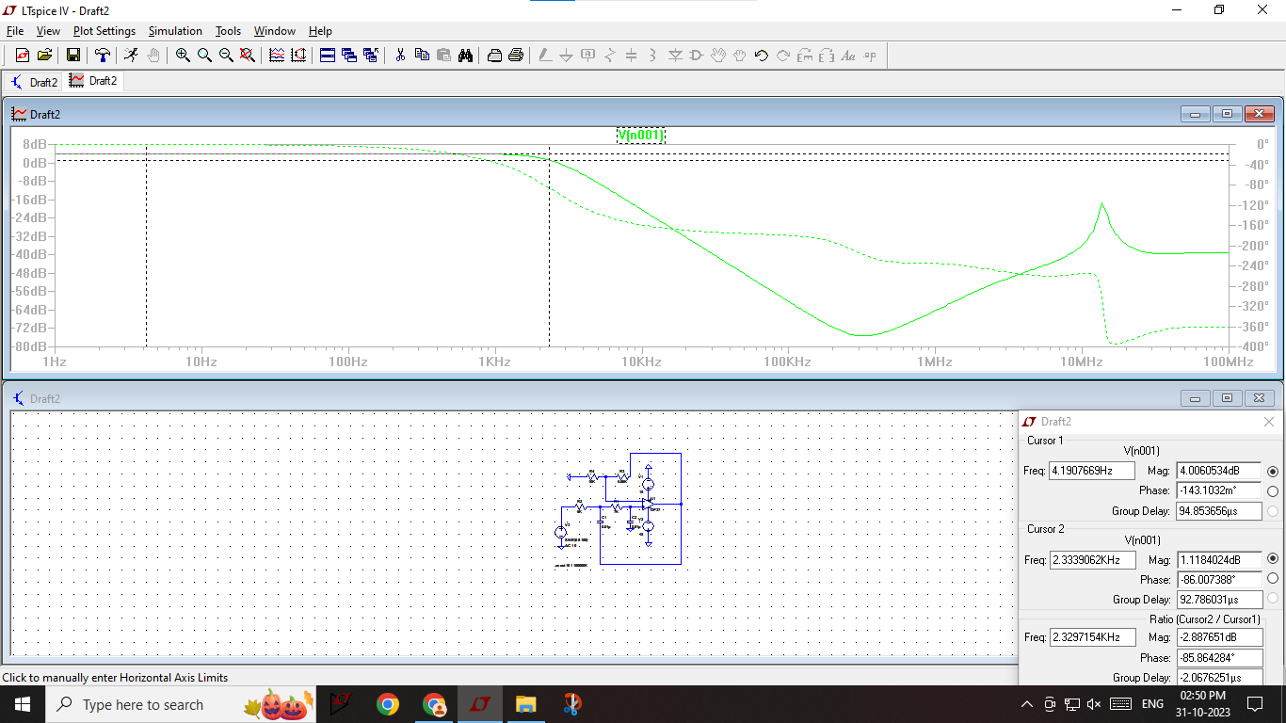

1. Edit simulation command to AC analysis and begin simulation(when resistance are different that is 6k and 7k both side greater than 5.3k).



1. Prepare an R-2R ladder for DAC.

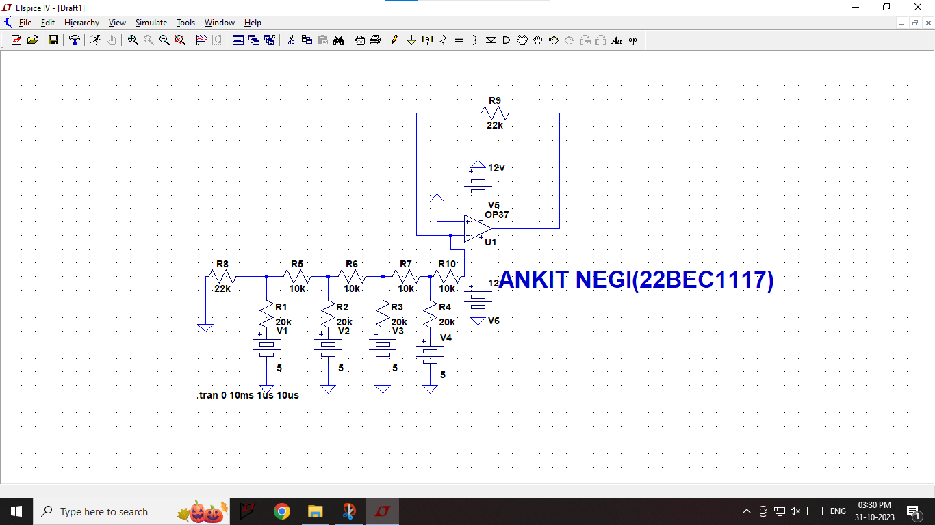

1. Analyze the change in voltage while increasing the binary values.

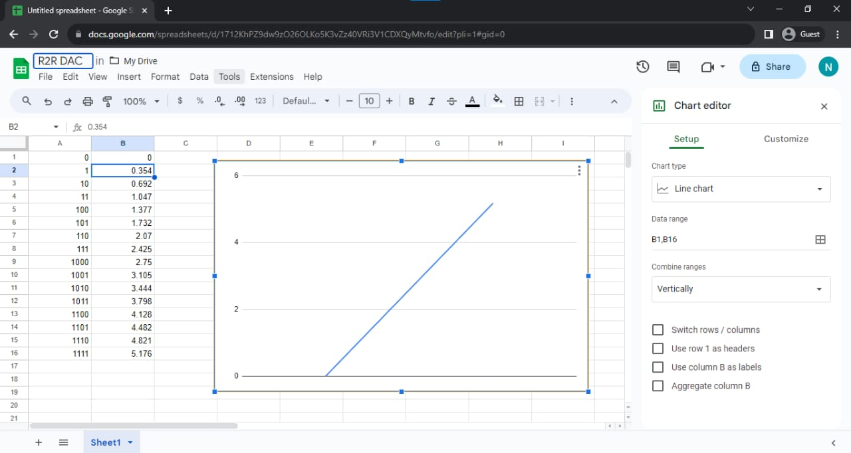

**OBSERVATION:**

1. The Second Order Low Pass Filter circuit underwent comprehensive analysis encompassing DC analysis for steady-state output determination, transient analysis to study time-dependent response to varying inputs, and AC analysis for frequency response characterization, leveraging the jockey tool to probe input and output terminals across these analyses.
2. The R-2R Ladder DAC circuit was constructed and simulated using transient analysis with specific input voltages for all 16 binary combinations (0000 to 1111). Output voltage values corresponding to each binary input were recorded and noted down for further analysis and plotting

**RESULTS:-**

1. A Second Order Low Pass Filter is designed to attenuate higher frequency components in an input signal while allowing lower frequency components to pass through. This type of filter is particularly valuable in applications where it’s essential to eliminate noise or unwanted high-frequency signals from an input. The second-order design implies that the roll-off of the filter’s frequency response is steeper compared to a first-order filter. By employing capacitors and resistors in specific configurations, this filter effectively separates high and low-frequency components, finding applications in audio systems, communication devices, and signal processing.

2.For the R-2R Ladder DAC, the recorded output voltages corresponding to each binary input allow for the plotting of the DAC’s transfer characteristic curve, demonstrating the relationship between digital input values and analog output voltages. This provides a visual representation of the DAC’s performance and linearity.